4.1 Dataset

In this study, we leverage the unique and comprehensive Swimcat dataset, comprising a total of 2100 cloud images captured over a period of 17 months in Singapore using the calibrated ground-based whole sky imager, WAHRSIS. The dataset is meticulously categorized into six distinct classes, namely clear sky, patterned clouds, thin white clouds, thick dark clouds, thick white clouds, and veil clouds as shown in figure 1. Each type of cloud is responsible for different amount of rainfall as shown in table 1. The images, each measuring 125x125 pixels, offer a detailed and diverse representation of atmospheric conditions observed during the study period from January 2013 to May 2014.

Figure 1 Swimcat cloud images

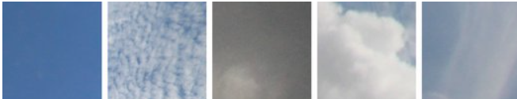



Table 1 rainfall classification based on cloud type

| **Cloud Type** | **Rainfall Potential** |
| --- | --- |
| Clear Sky | Little to no rainfall |
| Patterned Clouds | Little to no rainfall |
| Thin White Clouds | Little to no rainfall |
| Thick Dark Clouds | Moderate to heavy rainfall |
| Thick White Clouds | Moderate rainfall |
| Veil Clouds | Moderate to heavy rainfall |

4.2 Implementation details

The implementation of our research involved six distinct CNN models, including VGG16, DenseNet, NasNet, MobileNet, InceptionNet, and ResNet50, as outlined in Table 2. Hyperparameter tuning was conducted for batch size, optimizer, learning rate, and dropout rate, with details provided in Table 2. Transfer learning was applied by removing the top layer of each pre-trained model and freezing the remaining layers. A dense layer and a softmax layer were added as the final top layers, and backpropagation was employed for fine-tuning. Data augmentation techniques were also integrated to enhance dataset diversity but no improvement was seen, so we worked on non-augmented data only.

Table 2 hyperparameter table

|  |  |  |  |  |  |  |
| --- | --- | --- | --- | --- | --- | --- |
| Network | Year | Size(mb) | Depth | Learning Rate | Total parameters | Accuracy (%) |
| VGG16 | 2014 | 129 | 23 | 0.001 | 21,139,014 | 96.54 |
| DenseNet121 | 2018 | 40 | 121 | 0.01 | 8,093,254 | 96.13 |
| NASNetMobile | 2018 | 30.8 | - | 0.01 | 5,358,234 | 94.51 |
| MobileNet_V2 | 2017 | 24.1 | 88 | 0.01 | 3,575,878 | 92.88 |
| ResNet50_V2 | 2016 | 384 | 50 | 0.01 | 126,332,422 | 92.27 |
| Inception_V3 | 2015 | 233 | 159 | 0.001 | 21,802,784 | 91.26 |

4.3 Results and analysis

In our research, we explored the efficacy of various Convolutional Neural Network (CNN) models for predicting rainfall based on cloud images categorised into six distinct types. The accuracy acquired by each model is shown in Table 3. Among the models evaluated, VGG16 exhibited the highest accuracy of 96.54%, making it the top performer in our analysis. Following closely behind, DenseNet121 demonstrated an impressive accuracy of 96.13%, despite its smaller size and fewer parameters compared to VGG16. This suggests that DenseNet121 could serve as a compelling alternative, offering comparable performance while being more resource-efficient. We further

| **Model Name** | **Total Parameters** | **Accuracy (%)** |
| --- | --- | --- |
| VGG16 | 21,139,014 | 96.54 |
| DenseNet121 | 8,093,254 | 96.13 |
| NASNetMobile | 5,358,234 | 94.51 |
| MobileNet_V2 | 3,575,878 | 92.88 |
| ResNet50_V2 | 126,332,422 | 92.27 |
| Inception_V3 | 21,802,784 | 91.26 |

assessed the models using other parameters like f1 scores, precision, recall, and accuracy

of each class of cloud images using different models. However, due to lack of space, we only showed the result of accuracy and f1 score of each class using different models in chart 1. Our findings underscore the potential of CNN models, particularly VGG16 and DenseNet121, in accurately predicting rainfall from cloud images, providing valuable insights for weather forecasting applications.

Table 3 Accuracy of proposed CNN models

vgg-16

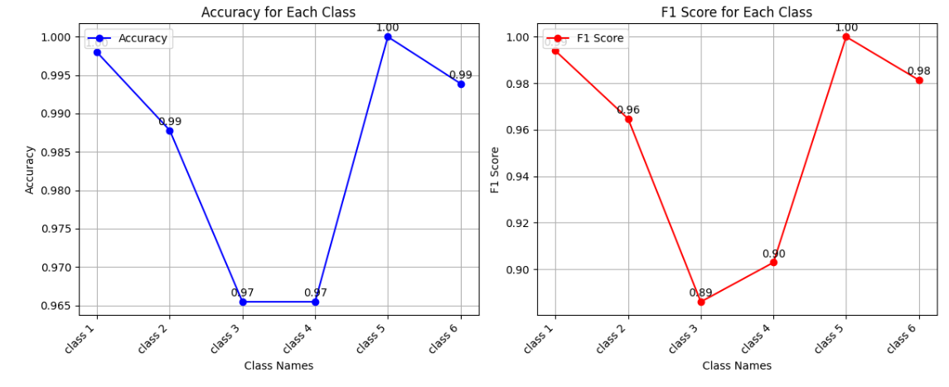

resnet_50:

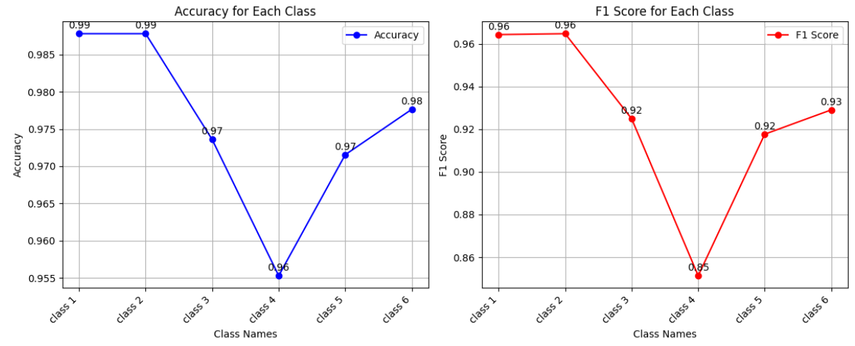

Inception:

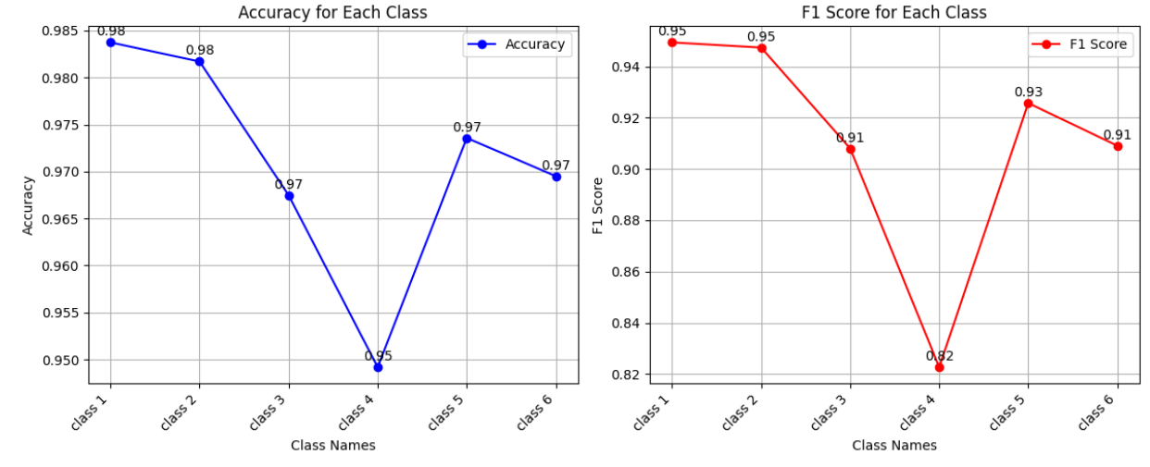

Mobile_net:

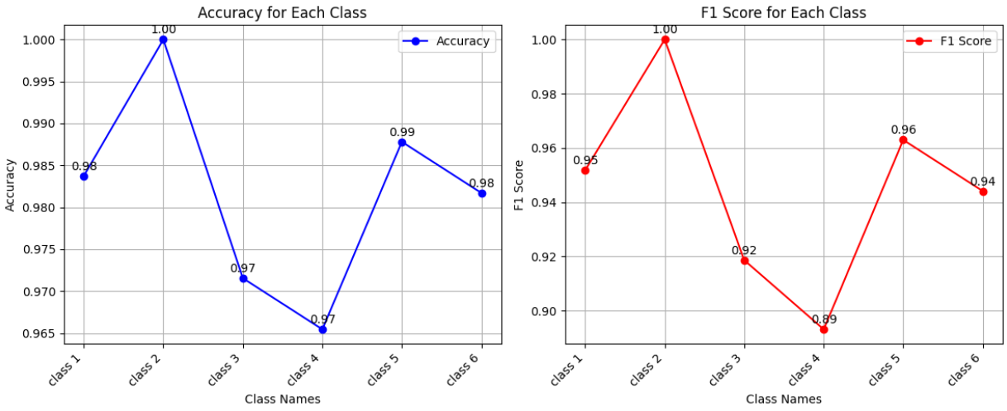

Dense net:

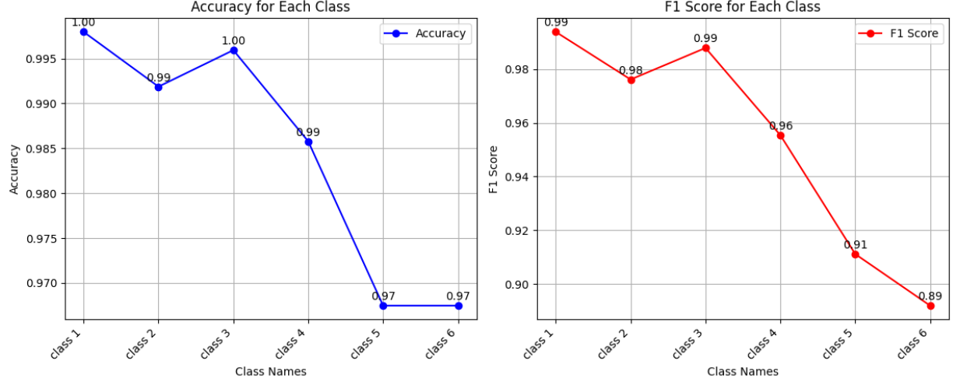

Nasnet:

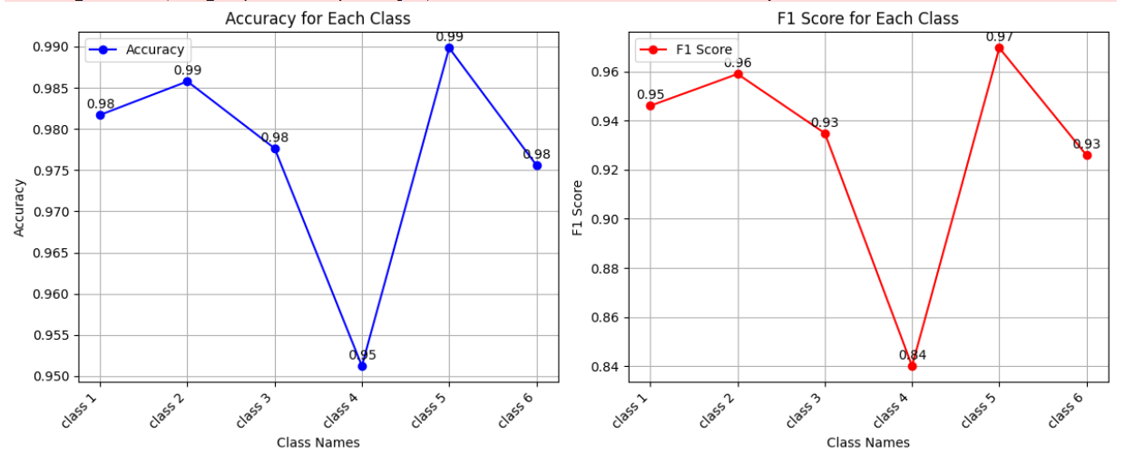––––––

**CHART 1**. containing f1 score and accuracy of all classes for all models